**Understanding Music**

**Higher**

**Revision Booklet**

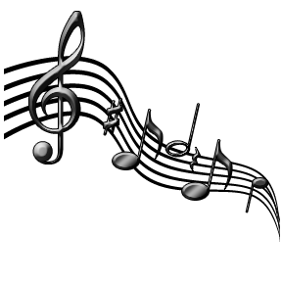

**Helpful Websites**

Type the following into Google and click the first result:

**NQMusic**

**Also try**

**Learn Listening Online** and **Music Listening Revision**

**Important concepts you need to know**

Obbligato: A featured solo instrument in a piece of Vocal music.

***Cadences:***

Plagal Cadence – 2 chords at the end of a phrase, section or piece of music. Chord IV to chord I. Gives a finished sound, but not as strong as a perfect cadence. Think ‘Amen’ at the end of a hymn.

Interrupted Cadence – 2 chords at the end of a phrase, section or piece of music. Chord V to another chord that isn’t chord I. Gives a feeling of being about to finish and then ending in a way which sounds unfinished or incomplete.

Tierce de Picardie – A name for a cadence at the end of a piece in a Minor key, where the final chord is Major.

***Scales:***

Relative Major/Minor – A major key and a minor key which have the same sharps/flats in the key signature. They are 3 semitones apart (eg. C major and A minor)

Harmonic Minor Scale – A minor scale which shares the same key signature as the relative major, but raises the 7th note by a semitone (eg. C Harmonic Minor – C D Eb F G Ab B C). Has an “Eastern/Egyptian” sound.

Melodic Minor Scale – A minor scale which shares the same key signature as the relative major, but raises the 6th and 7th notes by a semitone when ascending and when descending follows the key signature.

Mode/Modal – The music is based on Modes (early versions of Scales) and usually sounds like a cross between a Major and Minor key.

***Chords***

Added 6th – Major chord + the 6th note of the scale (eg. C6 – C E G A). Sounds Jazzy.

Dominant 7th – Major chord + the flattened 7th of the scale (eg. C E G B*b*). Can sound Jazzy/Bluesy and can be used in Perfect Cadences.

Diminished 7th – A chord built up using minor 3rds (eg. C E*b* G*b* A). Can sound scary or creepy or be used to modulate into distant keys.

***Ornaments***

Acciaccatura – A very short, crushed grace note played before the main note.

Mordent – Two notes played quickly before the main note. Either:

the main note, the note *above*, then the main note ***or*** the main note, the note *below*, then the main note.

**Interval** – The distance between two pitches. Tone, Semitone, Octave. Also 2nd, 3rd, 4th, 5th, 6th, 7th. Count up from the lowest note (count the lowest note as 1!)

***Rhythmic***:

**Time changes** – The time signature changes

**Irregular Time Signature** – Time signature where each bar does not divide equally into **EITHER** groups of 2 (simple time) or groups of 3 (compound time).

**Augmentation** – Compositional technique where each note value is systematically lengthened (eg. doubled – crotchets become minims etc.) Effect is that the music sounds slower.

**Diminution** – Compositional technique where each note value is systematically shortened (eg. halved – crotchets become quavers etc.) Effect is that the music sounds faster.

***Structure/Form:***

**Lied** – German Classical/Romantic era songs. Voice accompanied by Piano. Piano accompaniment adds to the mood set by the singer.

**Through Composed**: Structure where no section is repeated (i.e. no verse/chorus Strophic structure).

**Da Capo Aria** – A solo song from an Opera/Oratorio, which is in Ternary (ABA) form. On the repeat of the A section, the singer would add ornamentation.

**Passacaglia** – A set of variations over a Ground Bass.

**Concerto Grosso** – A Baroque style of composition for a small group of Solo Instruments (Concertino) accompanied by a larger group of accompanying instruments (Ripieno). Can also contain Basso Continuo.

**Basso Continuo** – a Baroque group of accompanying instruments made up of a Bass instrument (Cello/Double Bass/Organ pedals) and a chordal instrument (Harpsichord/Organ Keyboards/ Lute/Guitar).

**Ritornello** – A recurring short theme in a piece of Music. Name given to the theme played by the Ripieno in a Concerto Grosso.

**Subject** – The main theme in a composition.

**Sonata Form** – A structure used in Concertos, Sonatas, Symphonies and other styles of music. Has 3 sections. The opening section, the Exposition, introduces 2 main subjects or themes.

***Timbre:***

**Tremolando** – A string playing technique. Players move the bow rapidly up and down to create an agitated, restless, nervous sound.

**Harmonics** – A string playing technique. Players press lightly on the string. On Orchestral strings, Harp and Guitar this creates a bell-like sound. On Electric Guitar using distortion, this creates ‘squealing’ sounds.

**Coloratura** – Florid, highly decorated singing involving scales, ornaments and melisma.

***Styles:***

**Plainchant** – Also known as Gregorian Chant or Plainsong. The earliest known style of Vocal Music. Sung unaccompanied, in Unison, in Latin with no fixed time signature.

**Mass** – Religious Choral music for the Roman Catholic Mass. Renaissance Masses were Polyphonic and sung A Cappella. Listen for the words Kyrie Eleison/Gloria/ Credo/Sanctus/Benedictus/Agnus Dei at the start.

**Recitative** – Vocal music used in Opera and Oratorio where the music follows the rhythms of speech. Usually contain very sparse accompaniment and followed by an Aria.

**Sonata** – A piece of music for either (i) Solo Instrument, (ii) Solo Piano or (iii) Solo Instrument + Piano

**Chamber Music** – Music written for small groups of instruments (eg. String Quartet, Piano Trio etc.)

**String Quartet** – A Chamber Music group which contains 2 Violins, 1 Viola and 1 Cello. Popular from the Classical Era onwards.

**Oratorio** – A religious (usually Biblical) story set to Music. Includes Aria, Recitative and Chorus – sound similar to Opera – listen to lyrics!

**Impressionist** – Music from around 1900 which mirrors the slightly blurred art of the same period. This effect was created by using Cross-Rhythms, tying notes across barlines and use of the Sustain pedal on the piano.

**Musique Concrète** – 20th Century Style of music where recorded natural sounds are altered by cutting and

re-ordering, changing the speed, playing backwards etc.

**Jazz-Funk** – 20th Century style of music that fuses Electronic/Amplified instruments and Synthesizers with elements of Jazz such as improvisation, Riff/Ostinato accompaniment, Syncopation

**Soul** – A combination of Afro-American Gospel, Blues and Jazz music. Sounds funky, rhythmic and sung with lots of expression.

**Homophonic** – **Texture** - all parts move at same time or melody with accompaniment – same rhythms at the same time.

**Polyphonic** – **Texture** - 2 or more parts with different rhythms - weave independently of each other. Like **Contrapuntal**

**Legato** – Notes played long and smoothly

**Staccato** – Notes played short and detached

**Ostinato/Riff** - Repeated pattern of notes

**Sequence** – Pattern of notes repeated higher or lower

**Repetition** – Musical idea heard more than once.

**Imitation** –The melody is immediately copied by another instrument/voice

**Unison** – Same notes at the same time.

**Harmony** – Different notes at the same time.

**Anacrusis** – Tune starts before the first beat of the bar. Think “happy” in happy birthday.

**Syncopation** – Strongly accented notes playing off or against the beat. Will sound more jumpy/jazzy

**Symphony** – Piece for **whole orchestra**, no main solo instrument.

**Concerto** – Piece for **soloist** and orchestra

**Cadenza** – Section in Concerto for soloist to show off, sounds made up – improvised.

**A capella** – Unaccompanied voice(s) – no accompanying instruments.

**Melismatic** – **More than one** note per syllable.

**Syllabic** – **One** note per syllable.

**Major** – Happy, positive sounding.

**Minor** – Sad, scary, tense sounding.

**Atonal** – Not major or minor – uses dissonance – doesn’t sound nice.

**Forms** - **Binary** – 2 sections – A & B **Ternary** – 3 sections A B A

**Rondo** – Lots of sections with A repeated

eg. A – B – A – C – A – D

**Theme & Variations** – Main theme is played and then changed in a different way each variation eg. put into minor key, notes added to tune, different beats in a bar.

**Alberti bass** - Broken chords played by the left hand on the piano. Low - high – middle – high.

**Walking Bass** – Bass notes move on every beat.

**Ground Bass** - A theme in the bass which is repeated many times while the higher parts change.

**Broken chord** – Notes of the chord played separately.

**Vamp** – Oom-cha accompaniment. Bass note then chord.

**Simple time** – Each beat splits into 2 equal parts – COF-FEE

**Compound time** – Each beat splits into 3 equal parts – STRAW-BER-RY

**Aria** – Main song in an opera. Shows off the singer’s ability-tuneful.

**Cadence** – Last 2 chords in a phrase.

**Perfect Cadence** = sounds finished

**Imperfect Cadence** = sounds unfinished.

**Tierce De Picardie** – Minor key with last chord major.

**Pedal** – **Low** note held on or repeated while other parts change.

**Inverted Pedal** - **High** note held on/repeated while other parts change

**Modulation** – Change of key.

**Voices – Highest to lowest**

**Soprano**

**Mezzo Soprano** **FEMALE**  
**Alto**

**Tenor**

|  |  |  |  |
| --- | --- | --- | --- |
|  | **Dynamic** | **Italian** | **English meaning** |
|  | ***pp*** | *Pianissimo* | very quiet |
|  | ***p*** | *Piano* | quiet |
|  | ***mp*** | *Mezzo-piano* | moderately quiet |
|  | ***mf*** | *Mezzo-forte* | moderately loud |
|  | ***f*** | *Forte* | loudly |
|  | ***ff*** | *Fortissimo* | very loudly |
|  | *cresc.* | *Crescendo* | Gradually getting louder |
|  | *dim.* | *Diminuendo* | Gradually getting softer |

**Baritone** **MALE**  
**Bass**

**DYNAMICS – VOLUME**

**TEMPO - SPEED**

|  |  |
| --- | --- |
| **Tempo** | **Meaning** |
| ***Adagio*** | Slow |
| ***Andante*** | Walking Pace |
| ***Moderato*** | A Moderate Speed |
| ***Allegro*** | Fast |
| ***Accelerando*** | getting faster |
| ***Rallentando*** | getting slower |
| ***Rubato*** | speeding up/slowing down make the music more expressive |

**Musical Eras**

**Before Baroque**

Plainchant/Mass/Modal

**Baroque**

Small orchestras – mostly Strings with 2-5 brass/ woodwind players added for colour. Harpsichord! Music usually sounds ‘busy’. Focus on polyphonic texture.

**Classical**

Larger orchestra than Baroque. No Harpsichord. More strings + 1 or 2 oboes, flutes, clarinets, bassoons. Move towards more homophonic styles.

**Romantic**

Much larger orchestra than Classical. More strings, often 3 or 4 of each woodwind and brass instrument. Dramatic music. Lots of contrasts and extremes of dynamics. More chromaticism and more frequent modulation.

**Instruments & Related Concepts**

**Strings Concepts/Playing Technique**

**Violin Arco -** Bowed

**Viola Pizzicato -** Plucked

**Cello Tremolando** – Fast, short bowing. Sounds ‘anxious’

**Double Bass Harmonics** – High, eerie, thin sound

**Harp** / **Clarsach**

**Woodwind**

**Piccolo Blowing -** Air is blown through

**Flute** instrument to produce sound

**Oboe**

**Clarinet**

**Bassoon Flutter Tonguing -** Rolling your Rs while

blowing a note.

**Saxophone**

(not in orchestra)

**Brass**

**Trumpet Con Sordino** **- Muted** - creating a different

**French Horn** sound than normally

**Trombone** expected.

**Tuba**

**Percussion** **Untuned Percussion**

**Tuned Percussion** Snare Drum Bodhran

Drum-kit Bongo Drums

Xylophone(wooden) Cow Bell Guiro

Glockenspiel(metal) Bass Drum Castanets

Vibraphone Cymbals Tambourine

Timpani (kettle drum) Triangle

Tubular Bells

**Musical Groups / STYLES**

**Orchestra** - Strings, Brass, Woodwind, Percussion

**Brass Band** - Brass & Percussion

**Wind Band** - Brass, Woodwind, Percussion

**Folk Group** - Fiddle, Guitar, Vocals, Accordion,

Whistle, Flute, Bodhran

**Scottish dance band** - Fiddle, Accordion, Piano, Drums.

**Celtic Rock** - Mixes folk music with amplified instruments

**Reggae** - Off beat guitar, vocals, drums, organ, bass.

**Impressionist** - Sounds dreamy or blurry. Whole tone scale.

**Minimalist** - Simple and repetitive ostinatos.

**Ragtime**  - Piano. Syncopated melody & vamp accomp.

**Blues**  - Jazz style, developed from black American folk songs. Tells a story. Flattened notes.

**Swing** - A jazz style performed by a big band.

|  |  |  |  |
| --- | --- | --- | --- |
| **Dance** | **Speed** | **Beats** | **Other features** |
| **Waltz** | Slow/Medium | 3 | Only dance with 3 beats |
| **Jig** | Fast | 2 – 6/8 time | STRAWBERRY, compound time, |
| **Reel** | Fast | 4 | COFFEE, simple time, flowing |
| **Strathspey** | Medium | 4 | Jumpy, Scotch Snap |
| **March** | Marching speed | 2 or 4 | Steady, strong pulse. |

**Scottish Music**

|  |  |  |  |  |
| --- | --- | --- | --- | --- |
| **Song** | **Who?** | **Where/About?** | **Accomp?** | **Other?** |
| **Waulking Song** | Women | At **work** | No | Thumping sound |
| **Bothy Ballad** | Men | **Farm** work | Usually no | Tells story |
| **Gaelic Psalm** | Both | **Church** North Scotland | No | In Gaelic, Call & Response. |
| **Mouth Music** | Both | **Nonsense made up Gaelic words** | Maybe | Imitating melody of bagpipes |
| **Scots Ballad** | Both | Telling story | Maybe | Lots of verses and chorus. |

**Literacy Tips**

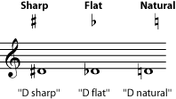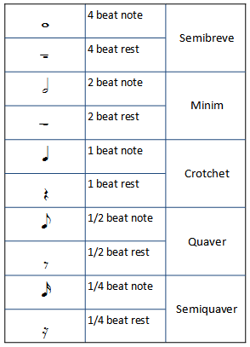

Remember a DOT after any note OR rest adds HALF the value on.

eg. a Dotted Crotchet is 1 + 1/2 = a 1 ½ beat note

a Dotted Quaver is 1/2 + 1/4 = a 3/4 beat note

a Dotted Minim is 2 + 1 = a 3 beat note

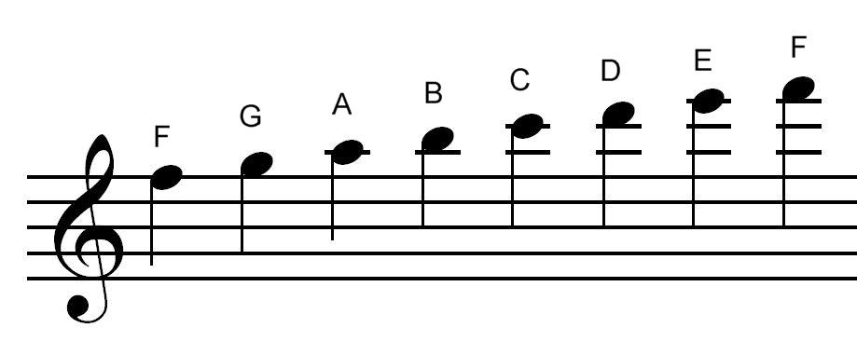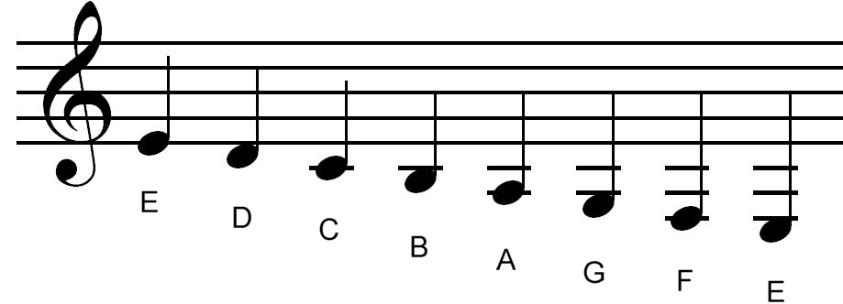**Treble Clef**

Notes Above the Stave

Notes Below the Stave

Spaces:

**FACE** in the space



Lines:

**E**very **G**ood **B**oy **D**eserves **F**ootball



**Bass Clef**

Lines:

**G**orillas **B**uy **D**oughnuts **F**rom **A**sda

Spaces:

**A**ll **C**ows **E**at **G**rass

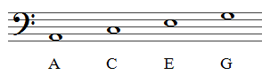

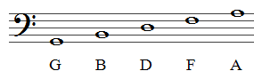

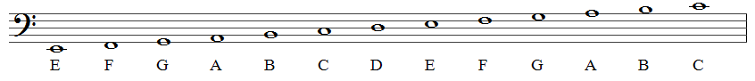

**Transposition Down 1 Octave to Bass Clef**

Transpose this down 1 octave into Bass clef:

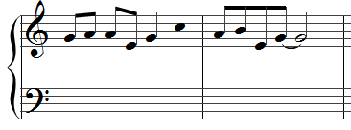

Write your answer on this stave

Use Middle C to help!

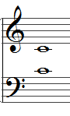

These 2 notes sound the same.

Lightly pencil in the Middle Cs onto the original:

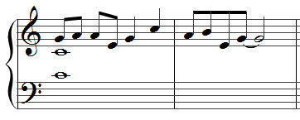

This first G is a 5th above middle C. Since this is less than 1 octave, the note in the Bass clef 1 octave lower will be the G immediately below middle C (not the bottom line G!)

Pencil in the 1st note:

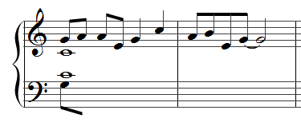

If the Treble Clef line moves up 1 note, the Bass Clef line does the same. If the Treble Clef lines moves up 2 notes, so does the Bass Clef line (etc).

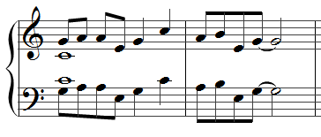

Check the note names match up.

Check that any sharps/flats/ties/slurs/staccato marks are also copied.

Remember to erase the Middle Cs you wrote in at the start!

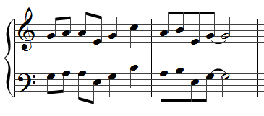

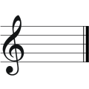**Key Signatures**

**C Major** = 0 sharps or flats

**A Minor** = 0 sharps or flats

+with G#s in music.

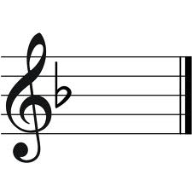

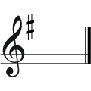 **F Major** = 1 flat *b*

**G Major** = 1 Sharp *#*

**Chords I IV V and VI in Major and Minor Keys:**

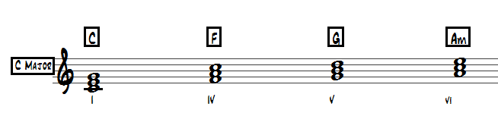

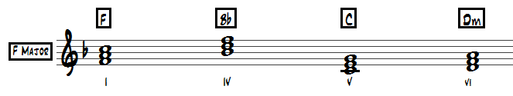

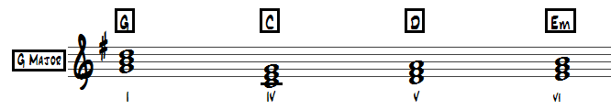

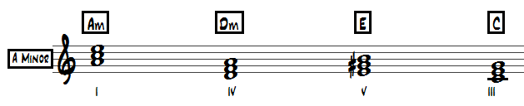

**Articulation Marks:**

Phrase mark

Accent

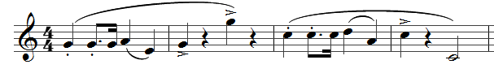

Staccato

Slur

Staccato – Play notes short and detached

Slur – Play 2 or more notes different smoothly together eg. in one breath.

Accent – Play the note louder than the rest.

Phrase mark – Shows a section of music (usually 2 bars or more) that make up a musical ‘Phrase’

**Repeat Signs**

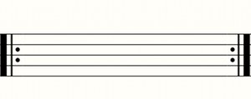

Start End

[](http://commons.wikimedia.org/wiki/File:Music-dacapo.png)= Da Capo (Go back and play from the beginning)

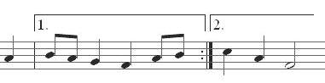

**1st & 2nd time bars**

Play ***only*** the 1st time bar the first time (then follow the repeat).

Play ***only*** 2nd time bar the second time (then carry on with any other music written).

**Intervals**

Intervals = the distance in pitch between 2 notes.

e.g. – those notes are a semitone apart

e.g. – those notes are an octave apart

You can also describe intervals using numbers

(2nd, 3rd, 4th, 5th, 6th , 7th)

This bracket shows the 2 notes involved

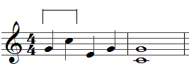

Count from +including the lowest note.

G up to C = G A B C = 4 notes = a 4th apart.

You can also be asked to describe 2 notes that are written to be played at the same time:

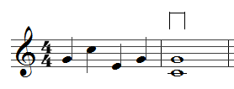

Notes are a C and a G = C D E F G = 5 notes = a 5th apart.

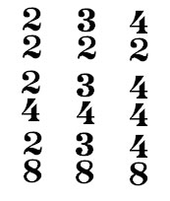**Time Signatures** –go right at the beginning of the first line – **beside the treble clef**.

= 2 crotchet beats per bar = 3 crotchet beats per bar

Simple time Simple time

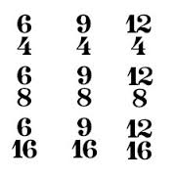

= 4 crotchet beats per bar = 6 quavers per bar (splits Simple time into 2 beats) Compound time

|  |  |  |  |  |
| --- | --- | --- | --- | --- |
| Melody  Harmony | Rhythm  Tempo | Instruments and  how they are used | | Dynamics |
| Repetition  Sequence  Imitation  Modulation  Chords/ Discords  Broken Chords  Suspensions  **Scales**: Major/Minor, Chromatic, Pentatonic  Question & Answer  Glissando  Homophonic/  Polyphonic  Ornaments: trill, grace notes  Legato /Staccato  Unison/Harmony  Pedal  Melismatic/  Syllabic | Syncopation  Repetition  Ostinato  Anacrusis  Beats in a bar /  Time Signature:  2/4, 3/4, 4/4, Simple Time  6/8 – Compound Time  Speed: Allegro – Fast  Adagio – Slow  Andante – walking pace  Moderato – moderate  Speed Changes:  Accelerando – faster  Rallentando – slower  Rubato – with freedom  Dotted Rhythms  Scotch Snap | **Brass** – Trumpet, French Horn, Trombone, Tuba  **Woodwind** – Piccolo, Flute, Oboe, Clarinet, Bassoon, Saxophone, Recorder  **Strings** – Violin, Viola, Cello, Double Bass, Harp  **Percussion** – Xylophone, Glockenspiel, Timpani, Triangle, Snare Drum, Drumkit, Bass Drum, Tambourine, Castanets  **Keyboard** – Piano, Synthesizer, Harpsichord, Organ  **Voices** – Soprano, Mezzo Soprano, Alto, Tenor, Baritone, Bass  **Guitars** – Electric, Acoustic, Bass, Banjo  Solo, Melody, Countermelody  Accompaniment, Chords, Broken Chords  Glissando, Arpeggios  Arco – bowed, Grace notes, ornaments  Muted, Pizzicato - plucked  Col Legno – wood of bow, Double Stopping  **Female**: Soprano, Mezzo Soprano, Alto  **Male**: Tenor, Baritone, Bass  Solo; Accompaniment; Melody; Countermelody | *pp – pianissimo – very quiet*  *p – piano* – quiet.  *mp* – *mezzo piano* – moderately quiet.  *mf* – mezzo forte – moderately loud.  *f – forte* – loud.  *ff – fortissimo* – very loud  **Changes of dynamic**  **crescendo** – getting louder  **diminuendo** – getting quieter. | |

**Categories**

**TONALITY**

**MAJOR MINOR ATONAL MODAL**

**STRUCTURE**

**BINARY FORM TERNARY FORM RONDO FORM**

**THEME & VARIATION STROPHIC SONATA FORM**

**THROUGH COMPOSED PASSACAGLIA**

**TEXTURE**

**HOMOPHONIC POLYPHONIC/CONTRAPUNTAL**

**PERIODS OF MUSIC**

**BAROQUE CLASSICAL ROMANTIC**

**New Higher – Understanding Music Paper Layout**

**Multiple Choice Questions**

Tick the boxes/write the concepts you are sure of.

Score out any you are sure do NOT appear.

Use sensible guesswork for remaining concepts.

**Musical Map - 5 Marks**

5 numbered boxes. Voice says the number over the music & you must answer the question in the related box when the number is said.

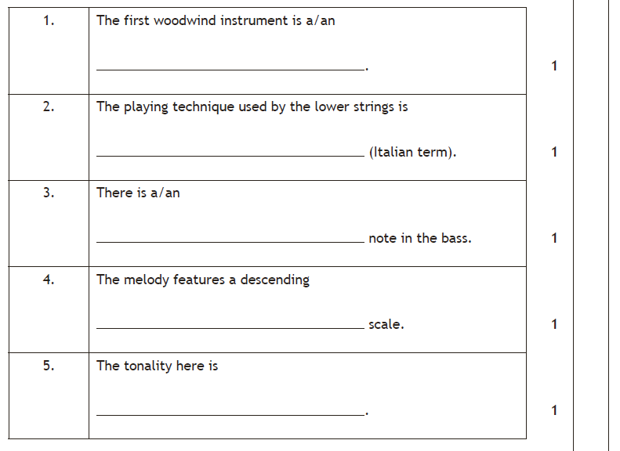

**‘Write the concepts’ questions**

Write in the correct concepts in the spaces provided.

Remember:

“…that describes the **Timbre**” = instruments/voices/effects

“…that describes the **texture**” = homophonic/polyphonic

“…that describes the **tonality**” = major/minor/atonal

“…that describes the **word setting**” = syllabic/melismatic

“…the **rhythmic** feature” = anacrusis/scotch snap/3 against 2/ cross rhythms (etc.)

“…the **ornament**” = acciaccatura/mordent/trill

“a ….. **scale**” = major/harmonic or melodic minor/chromatic/pentatonic/blues/whole tone

**Literacy question – 6 Marks**

e.g. Write in Time Signatures, identify Key Signatures, Describe intervals, write in notes/rests/bar lines, name the chords you hear, bass clef transposition, identify accents, staccato marks etc.

**Write the concept next to the lyrics – 5 Marks**

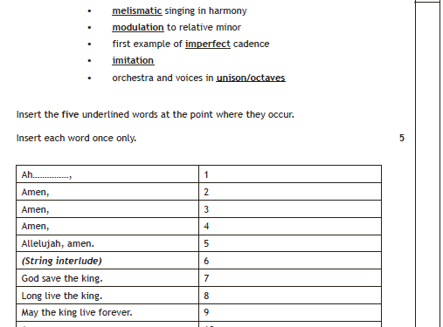

Write the underlined word next to the numbered line in which the concept occurs. Write each word **ONCE** only.

**Prominent features of the music - 6 Marks**

3 boxes worth 2 marks each.

Choose 2 strong and safe concepts for each box.

Then add any others you are sure of.

Possible boxes + safe concept choices are:

**Melody**: Ornaments, Scales, Repetition/Sequence/Imitation

**Harmony**: Cadences, Tonality

**Rhythm**: Time Signature

**Tempo**: Adagio/Andante/Moderato/Allegro/Accelerando/Rallentando

**Dynamics**: Crescendo/Diminuendo/Piano/Forte

**Timbre**: Instruments/Voices/Groups (Orchestra/String Quartet/SATB Choir/Ripieno etc)

**Texture**: Homophonic/Polyphonic

**Compare 2 excerpts question**

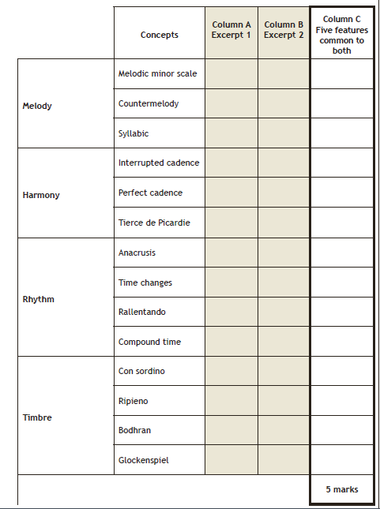

Tick boxes in Columns A and B when you hear concepts

Cross boxes in Columns A and B when you know they are definitely incorrect/incompatible (i.e. can’t be Baroque and Classical or Sonata and Concerto).

**LEAVE COLUMN C TO THE END!**